VehicleRentingSystem

Requirements Specification and Analysis

10.11.2019

Ahmet Can Terlikçi

Tunç Bora Tamsan

Duygu Genç

Bora Arseven

Prepared for

SE301 Software Engineering



Table of Contents

1. Introduction 1

1.1. Purpose of the System 1

1.2. Scope of the System 1

1.3. Objectives and Success Criteria of the Project 1

1.4. Definitions, Acronyms, and Abbreviations 1

1.5. Overview 1

2. Current System 1

3. Proposed System 1

3.1. Overview 1

3.2. Functional Requirements 2

3.3. Nonfunctional Requirements 2

Usability 2

Reliability 2

Performance 2

Supportability 2

Implementation 2

Interface 2

Packaging 2

Legal 2

3.4. System Models 2

Scenarios 2

Use case model 2

Object model 2

Dynamic model 2

User interface—navigational paths and screen mock-ups 3

3.5. Project Schedule 3

4. Glossary 3

5. References 3

REQUIREMENTS ANALYSIS DOCUMENT[1]

# Introduction

## Purpose of the System

Today, there are countless web sites in the context of vehicle renting in the market. But many of them have a common problem. They are too complicated and irresponsive for new customers. Our goal in this project is providing a fun to use and highly responsive website with the same functionality to the especially new customers.

Basicly, VehicleRentingSystem is a simple web-based car renting system which allows to the users renting different types of cars in specific countries and cities through the authorized offices of the company.

## Scope of the System

Deliverables: There will be two main deliverables in the project. One of them is the VehicleRentingSystem website with an appropriate GUI and users, and a proper database for the system.

Deadline: Final version of the project will be ready at the end of the current semester.

Main project goal: All users in the system must be able to carry out the operations specified in the functional requirements of the system with no type of error.

## Objectives and Success Criteria of the Project

The success of the project is depends on the following core set of objectives:

* The design of a GUI which is easy to use for the customers which did not use any type of vehicle renting system before.
* The implementation of the functions in the functional requirements of the project to validate that at least 90% of the specified functions is ready to use in the final project with no type of errors.
* The implementation of the users in the functional requirements of the project to validate that 100% of the specified users exists in the final project with at least 90% of their specified functions.

## Definitions, Acronyms, and Abbreviations

**Class name:** Type of the Vehicle such as economic, expensive, SUV or van.

**Model number:** Its an unique number that is assigned to the each Vehicle.

**Available luggage amount:** Its how much weight a Vehicle can carry in kg.

**Working hours:** It is the hours that an Office works.

**Fuel Type:** It is fuel type that Vehicles uses like fuel, disel or lpg.

**Daily Price:** It is payment that is required to rent a Vehicle per day.

**Number of Seats:** Passenger capacity of a Vehicle.

**Search panel:** Panel that is in the homepage of the website. It can be used to search Vehicles by entering an appropriate returning date, returning office, receiving date and receiving office.

**Document:** It is a type of word document. The customers in the VehicleRentingSystem, must be fill out some form before taking their Vehicles from Offices of the VehicleRentingSystem.

**Add office form:** This form appearswhen Administrator adds an office and it consist of the information of the Office specified in the functional requirements of the project.

**Add office user form:** This form appearswhen Administrator adds an OfficeUser to an Office and it consist of the fields about information of OfficeUser.

**Drop off Office:** Have same meaning with the returning office. The specified Office in the renting such that corresponding car must be returned to this place.

## Overview

The rest of the documents contains Current System part which explains how the tasks in the system are accomplished, Proposed System part which includes an functional overview of the system, functional and nonfunctional requirement of the system, System Models which consists of scenarios, use cases, overall use case diagram of the system and overall class diagram of the system, Glossary which explains the entity objects the system, and references which includes all type of sources.

# Current System

VehicleRentingSystem operates with the coordination of the system’s Offices. All Vehicles in the system are related to one of the Offices in the system and can be rent in the context of that Offices.

Customers can easily rent Vehicles through providing a proper receiving date, receving office, returning date and returning office to the system.

Rented vehicles can be received only from specified receiving office in the renting. The customers must fill out and sign some necessary documents before take their cars from Offices.

Documentation and delivery of the Vehicles is operated properly with the employeers in the Offices of the system.

Managemenet of the VehicleRentingSystem done by the selected Administrators in the system.

# Proposed System

## Overview

There four main users in the VehicleRentingSystem which are Visitor, RegisteredUser, OfficeUser and Administrator.

Visitors can search Vehicles, view all Offices and Vehicles in the system.

RegisteredUsers are simply customers. They can rent vehicles, change and update their personal information, view their rentings, extends the returning date of the current rentings and also change the returning of their current rentings.

OfficeUser are the employees in the Offices of the system. They can manage the rentings of the RegisteredUser.

Administrators are the managers or techinal employees of the system. They have absolute authority in the system. They can manage Offices, Vehicles and OfficeUser in the system.

## Functional Requirements

1. A User can list avaliable vehicles by providing receiving date, receiving office, returning date and returning office.
2. A RegisteredUser can rent vehicles by providing his/her billing information and personal information.
3. A RegisteredUser can display the information of the vehichles that she/he rented.
4. A RegisteredUser can extend the date of the his or her rents.
5. A RegisteredUser can change the returning Office of a current renting.
6. An Administrator can add new Offices to system and remove Offices from the system.
7. An Administrator can update the Offices in the system.
8. An Administrator an add new Vehicles to system and remove Vehicles from the system.
9. An Administrator can update the Vehicles in the system.
10. A RegisteredUser can change his/her personal information in the system which are name, surname, phone, e-mail, birthdate, gender, driver’s licence information, address, city and country.
11. A Visitor can register the system through providing his/her name, surname, username, e-mail and password.
12. A SystemUser can enter the system by providing his/her username and password.
13. A OfficeUser can view and update the rentings of the Users.
14. A RegisteredUser can use discounts when rent a vehicle.
15. A User can filter the search results of the Vehicles in terms of classes, gear types and fuel types after completed a search for a specific instance.
16. A User can change the receiving date, receiving office, returning date and returning office of the search after completed a search for a specific instance.
17. An Administrator can update the OfficeUsers in the system.
18. A SystemUser can change his/her password in the system.
19. An Administrator can add OfficeUsers to the system and remove OfficeUsers from the system.
20. There must be six type of users in the system which are User, Visitor, SystemUser, RegisteredUser, OfficeUser and Administrator.
21. RegisteredUser, OfficeUser and Administrator are SystemUsers.
22. SystemUsers and Visitors are Users.
23. In the system, there must be Offices denoted as their name, address, e-mail, phone, fax, working-hours, city and country.
24. In the system, there must be Vehicles denoted as their model number, plate number, physical status, renting status, daily price, class, gear type, fuel type, number of seats, avaliable luggage, minimum driver’s age, minimum years of license, brake system, avaliability of airbags, avaliability of air conditioning and the name of the current Office.
25. In the system, there must be RegisteredUsers denoted as their name, surname,username, password, birthdate, phone, e-mail, gender, address, city, country and driver-license information.
26. In the system, there must be Administrators denoted as their name, username and e-mail.
27. In the system, there must be OfficeUsers denoted as their name, surname, birthdate, phone,office, e-mail, username, password, gender, address, city and country.
28. Offices and Vehicles of the VehicleRentingSystem must be displayed on the website to all type of users. Offices must be categorized as their countries and cities, in the other hand, the Vehicles must be categorized as their classess.

## Nonfunctional Requirements

### Usability

1. The search panel on the main page of the website must be auto-scaled for different types of resolutions.
2. In the search results of the Vehicles, at most 10 cars must be displayed on one page.
3. A person which is never use any vehicle renting system before, must be able to rent a vehicle from VehicleRentingSystem in 15 minutes.
4. A searching panel to list avaliable vehicles for renting must be presented only on the main page of the website.

### Reliability

1. The VehicleRentingSystem must prevent to rent the Vehicles with the “damaged” physical status.

### Performance

1. The search function in the system must be display a result at most 30 seconds.
2. VehicleRentingSystem must send e-mails to the users in 1 minutes after a user completed a renting.

### Implementation

1. VehicleRentingSystem must be written in Java by using JavaServer Faces library.
2. VehicleRentingSystem must support the .jpg and .png image types.
3. VehicleRentingSystem must support the .pdf and .word document types.

## System Models

### 

### Scenarios

**Scenario Name** RentVehicle

**Participating Actor** Mehmet:RegisteredUser

**Instances**

**Flow of Events** 1. Mehmet wants to rent a vehicle for his holiday trip and enters the website of the VehicleRentingSystem.

2. Mehmet is a RegisteredUser in the VehicleRentingSystem. Therefore he enters login page of the website and logs in by using his username and password.

3.After login, Mehmet notices the search panel in the main page

of the website.

4. He enters the receiving date, receving office, returning date and returning office to the search panel and activates the search function of the system.

5. Mehmet searches through the lists of corresponding vehicles to a find appropriate one for him.

6. Mehmet finds a Mercedes SUV with a daily price of 300 dollar.

7. Mehmet selects the car and adds to its chart.

8. Next, Mehmet opens his chart and goes to the checkout.

9. Because of he is a member of the system, he notices the automatic filled personal information in the website.

10. He checks the information and moves the payment information section.

11. Then, he enters his name, surname, address, social security number and credit/debit card information and confirms the checkout.

12. After that, he notices the “Your rent is done succesfully.” information on the website and an takes a new e-mail which includes a complete information about his renting.

**Scenario Name** CheckTheReceivingDate

**Participating Actor** Mehmet:RegisteredUser

**Instances**

**Flow of Events** 1. Mehmet is a member of the VehicleRentingSystem website and yesterday, he rented a Mercedes SUV for 1 week. Now, he wants to check the receiving date and all other information of his renting. Because he rented the vehicle to a future date. 2. Mehmet enters the website and logs in with his username and password.

3. Then, he enters the “My Profile” page of the website and from there, he moves to the “My Rentings” page of the website. 4. He notices his rent in the first place and opens it to see further information. 5. Next, Mehmet notices the receiving date of his renting and all other information.

**Scenario Name** UpdateTheRenting

**Participating Actor** Mehmet:RegisteredUser

**Instances** Kenan:OfficeUser

**Flow of Events** 1. Mehmet is member of the VehicleRentingSystem website and rented a car for his holiday trip. Today, he will go the receiving office of the renting and take his car.

2. First, Mehmet goes to the receiving office by a bus and enters the building.

3. Next, he takes a queue number from the machine at the entry of the office and waits for his turn. 4. His turn comes and Mehmet goes to the desk of the Kenan.

5.Then, he gives his ID to the Kenan and says that he has come here to take his rented car.

6. Kenan enters the social security number of the Mehmet to the system from his computer and reaches his renting information.

7. After that, Kenan checks the status of the renting and notices that it is “Do not received.”. 8. Next , to be able to update Mehmet’s renting status to

“Received.” Kenan prints specified documents in the system. 9. Then, Kenan gives the documents to the Mehmet and wants to fill out and sign all of them. 10. Mehmet fills out the documents and gives back to the Kenan.

11. Kenan examines the documents and compares it with the information on the website.

12. Next, Kenan validates the documents, scans and uploads them into the Mehmet’s renting. 13. After that, Kenan saves the changes in the renting, prints a given document from the website which includes some

information about renting and confirms the changes in the

renting.

14. Kenan notices a response from the system as “Renting saved succesfully.”.

**Scenario Name** UseDiscount

**Participating Actor** Mehmet:RegisteredUser

**Instances**

**Flow of Events** 1. Mehmet is a frequent user of the VehicleRentingSystem and he already has two %5 discounts ready to use. Now, he wants to rent a vehicle to visit his grandpa which lives in a remote village. Therefore, he enters the website of the

VehicleRenting system and logs in with his username and password. 2. Then, he enters the corresponding receiving date, receiving

office, returning date and returning office informations to the search panel of the website. 3. He activates the search function of the system and notices listed cars on the webpage. 4. He uses the class filter to find a appropriate SUV car for him.

5. He finds a Toyota SUV with 150 dollar daily price and adds it to his chart. 6. Then, Mehmet enters his chart and selects one of his discounts by using a panel. 7. He notices that the total price of the renting is reduced 5%.

**Scenario Name** UpdateTheVehicles

**Participating Actor** Kenan:Administrator

**Instances**

**Flow of Events** 1. Kenan is a Administrator in the VehicleRentingSystem which is responsible for the region Marmara. Toyota has announced a problem in their 2015 model Toyota Corolla cars and therefore calls back them to repair. Kenan is received this information from the company and he is responsible to update physical status of a 2015 model Toyota Corolla cars in one of the Offices of his region.

2. He enters the VehicleRentingSystem and logs in with his username and password. 3. Then, he enters the Offices page of the website and locates the corresponding office.

4. He activates the manage the office function of the website. 5. After that, he notices that the information page of the corresponding office is opened on the website. 6. He activates the list the vehicles function of the system and notices that a list of the vehicles of the corresponding Office is displayed on the website. 7. He locates one 2015 model Toyota Corolla and activates the manage the vehicle function of the system. 8. After that, he notices that a page which shows the information of the vehicle is opened on the website. 9. He changes the physical status of the car as “damaged” and confirms his input. 10. Then, he receives a respond from the system which is “Saved succesfully”.

Scenario name ListVehicles

Participating actor Emily:RegisteredUser

instances

Flow of events 1. Emily will go out with her friends in this Thursday night

and she wants to rent a car. She wants to pick the car in

Istanbul Office and on the following day, she plans to

drop off the car back into Istanbul Office.

2. She goes into the VehicleRentingSystem website and

she enters the homepage.

3. Emily logs into her account by entering her username

and her password.

4. Emily enters the website as RegisteredUser.

5. Emily moves into the search panel and in this panel, she

enters the name of the receiving office,

name of the returning office, the

receiving date of the vehicle and the

returning date of the vehicle.

6. She activates the search function from the search panel.

7. After that, she notices the vehicles as listed with their

model name and with their daily rental prices tagged

on it according to the information she entered on

search panel.

Scenario name ExtendRentDate

Participating actor Emily:RegisteredUser

instances

Flow of events 1. Emily wants to extend her renting of Mercedes I300

by 2 days more.

2. She goes into the VehicleRentingSystem website and

enters the homepage.

3. Emily logs into her account by entering her username

and her password.

4. Emily enters the website as RegisteredUser.

5. Emily goes into the “My Profile” page of the website.

6. Then, Emily moves into the “My Rentings” which

appears on the page in the first place.

7. She notices that her rentings displayed as a list on the

page.

8. She goes into the details of her Mercedes I300 renting

and she changes the returning date.

9. She notices a message about the change in the date is

approved and the returning date of vehicle is

successfully extended.

Scenario name ChangeReturningOffice

Participating actor Emily:RegisteredUser

instances

Flow of events 1. Emily wants to change her returning office of her

Mercedes I300 renting to a different one which is Izmir

Office.

2. She goes into the VehicleRentingSystem website and

enters the homepage.

3. Emily logs into her account by entering her username

and her password.

4. Emily enters the website as RegisteredUser.

5. Emily goes into the “My Profile” page of the website.

6. Then, Emily moves into the “My Rentings” which

appears on her profile page in the first place.

7. She notices that her rentings displayed as a list on the

page.

8. She goes into the details of her Mercedes I300 renting

and She activates the change returning office function.

9. She notices a list of appropriate office locations

displayed by VehicleSystem on this page. Then she

selects one of the offices on the list and activates the

Save the Returning Office function.

10. She notices a message about the change in the office

location is approved and the returning office location of

vehicle is successfully changed.

Scenario name UpdateTheRenting

Participating actor Rose :OfficeUser

instances Emily:RegisteredUser

Flow of events 1. Emily rented a car from VehicleRentingSystem 5 days before and today, he needs to return his car to the stated returning Office at 10 a.m. 2. Therefore, he goes to the corresponding Office of the VehicleRentingSystem before 10 p.m. 3. He meets with the Rose which is a OfficeUser in this Office of the VehicleRentingSystem. 4. Rose enters the VehicleRentingSystem with her username and password. Then, she request the social security number of the Emily. 5. After that, he locates the corresponding renting of the Emily and activates the complete the renting function of the system. 6. She notices that before activate this function, she needs to uploads some documents to the renting which is filled by Emily. 7. Therefore, she prints the documents and gives to the Emily to fill out. 8. Emily fills out and signs the documents. 9. Rose checks the documents by using information on the Rose’s renting. 10. After that, Rose upluoads to the documents and again activates the complete the renting function of the system. 11. She notices a responds from the system such that “Renting is completed succesfully”.

Scenario name ChangeTheSearch

Participating actor Emily:RegisteredUser

instances

Flow of events 1. Emily will go out with her friends in this Thursday night

and she wants to rent a car. She wants to pick the car in

Istanbul Office and on the following day, she plans to

drop off the car back into Istanbul Office.

2. She goes into the VehicleRentingSystem website and

she enters the homepage.

3. Emily logs into her account by entering her username

and her password.

4. Emily enters the website as RegisteredUser.

5. Emily moves into the search panel and in this panel, she

enters the name of the receiving office,

name of the returning office, the

receiving date of the vehicle and the

returning date of the vehicle.

6. She activates the search function from the search panel.

7. After that, she notices the vehicles as listed with their

model name and with their daily rental prices tagged

on it according to the information she entered on

search panel.

8. Then, she receives a call from her friend which she finds

Her friend caught up to work and can’t make it on

Thursday but she’ll be available for Friday night.

Following, they agree on hanging out for Friday.

9. Because of that, she wants to change the returning date

of her search. Therefore, she activates the “change the

returning date of the search” function of the system and changes the returning date to the Friday.

10. After that, she activates the search function of the

system again and notices that appropriate Vehicles

for the new returning date is listed on the website.

**Scenario name** AddOffice

_________________________________________________________________________

**Participating** Pelin: Administrator

**actor** **instances**

_________________________________________________________________________

**Flow of events** 1. Pelin, logs in to the system with an administrator account with her

username and password . Then she opens the “Offices” page of the

website and activates the “Add new Office” function of the website.

2. After, she notices an empty form to add a new Office to the system

begins to fill out the form. The form is consist of the name, address,

e-mail, phone, fax, working-hours, city and country of the Office.

3. She fills out the form and confirms her input.

4. After that, Pelin notices a feedback from the website as

“Office is added succesfully.”.

**Scenario name** Login

_________________________________________________________________________

**Participating** Ali: RegisteredUser

**actor** **instances**

_________________________________________________________________________

**Flow of events** 1. Ali enters the VehicleRentingSystem website.

2. Then, he opens the login page of the website.

3. After, he notices a form which consists of username and password.

4. Ali enters his username and password to the form and confirms his input.

5. Then, Ali notices that the current web page is changed to the main page of the website and his name is displayed on the right-top of the website.

**Scenario name** SearchForVehicles

_________________________________________________________________________

**Participating** Ali: Visitor

**Actor** **instances**

_________________________________________________________________________

**Flow of events** 1. Ali wants to rent a vehicle for his holiday trip and he searches for

renting website in the web.

2. Then, he finds and enters the VehicleRentingSystem website.

3. After, he notices a search panel in the main page of the website.

4. He fiils out the blank fields in the panel which are receiving date,

receiving office, returning date and returning office.

5. Next, he confirms his input and notices that a list of Vehicles

is displayed in the website.

**Scenario name** FilterTheCars

_________________________________________________________________________

**Participating** Duygu: RegisteredUser

**Actor** **instances**

_________________________________________________________________________

**Flow of events** 1. Duygu enters the VehicleRentingSystem website.

2. Duygu, logs in to the system with a RegisteredUser account. She

enters the her username and password.

3. After, she notices a search panel in the main page of the website.

4. Duygu fills out the blank fields in the panel which are receiving date,

receiving office, returning date and returning office.

5. Next, she confirms his input and notices that a list of Vehicles

is displayed in the website.

6. After that, she filters the listed cars according to their classes, grear type and fuel type to list diesel auto gear SUVs.

7. Then, Duygu notices that the list of cars is updated as diesel auto gear SUVs.

**Scenario name** RemoveOffice

_________________________________________________________________________

**Participating** Cengiz: Administrator

**Actor** **instances**

_________________________________________________________________________

**Flow of events** 1. Cengiz, logs in to the system with an administrator account with his

username and password . Then he opens the “Offices” page of the

website, he search an office and activates the “Remove Office”

function of the website.

2. After that, Cengiz notices a feedback from the website as

“Office is removed succesfully.”.

**Scenario name** AddOfficeUser

_________________________________________________________________________

**Participating** Teyfik: Administrator

**Actor** **instances**

_________________________________________________________________________

**Flow of events** 1. Teyfik, logs in to the system with an administrator account with his

username and password . Then he opens the “Offices” page of the

website and he chooses an Office.

2. After, he notices a list of OfficeUser and he activates the “ Add

Offfice User “. Then he fill out the the OfficeUser information which are name, surname, birthdate, phone, office, e-mail, username,

password, gender, address, city and country. Then, he confirms his

input.

3. After that, Teyfik notices a feedback from the website as

“Office user is added succesfully.”.

**Scenario name** UpdateOfficeUser

_________________________________________________________________________

**Participating** Kenan: Administrator

**Actor** **instances**

_________________________________________________________________________

**Flow of events** 1. Ahmet is a office user and he want to change his Office. Thats why,

he reports the Administrator.

2. Kenan, logs in to the system with an Administrator account with his

username and password . Then he opens the “Offices” page of the

website and he chooses the Ahmet’s Office.

3. After, he notices a list of Office user and he selects Ahmet and he

activates the “Update Office User” function of the website.

4. Kenan, update the Ahmet’s Office and he saves the changing.

5. After that, Kenan notices a feedback from the website as

“Office user is updated succesfully.”.

**Scenario name** RemoveVehicle

**Participating actor** Hikmet: Administrator

**İnstances**

**Flow of Events**  1. Hikmet is the administrator of the system. Company wants to remove one of their cars which is a Toyota Corolla in the Istanbul Kadıköy Office and he have to remove this car from the website. Therefore, a document is given to the Hikmet from the company which includes required information about the car.

2. Hikmet opens the website and he logs in to the website with his username and password.

3.Then he opens the “Offices” pages of the website and searches for the Istanbul Kadıköy Office.

4. He finds the Office and activates the manage the Office function of the system.

5. After that, he activates the list the vehicles function of the system and notices that vehicles of the corresponding Office is listed.

6. He locates the corresponding Toyota Corolla and activates the remove the vehicle function of the system.

7. Then, he recevies a respond from the system such that “Vehicle is removed succesfully”.

**Scenario name** AddVehicle

**Participating actor** Hikmet: Administrator

**İnstances**

**Flow of Events**  1. Hikmet is a Administrator in the VehicleRentingSystem. Company has bought a new 2015 model Toyota Corolla for the Istanbul Kadıköy Office and he have to add this car to the website.

2. Hikmet opens the website and he logs in to the website.

3.Then he opens the “Vehicles” page of the website and activates the add vehicle function of the system.

4.After that, Hikmet enters the cars model number, plate number, daily price,class name, gear type, fuel type, number of seats, available luggage amount and its office address as its location.

5.Hikmet activates the add the vehicle function of the system.

6.After that, he notices the “the car added successfully” feedback on the screen.

**Scenario name** ChangePersonalInfo

**Participating actor** Kerim : RegisteredUser

**İnstances**

**Flow of Events**  1. Kerim is a RegisteredUser in the VehicleRentingSystem and he has changed his phone number therefore he also wants to change his number on the website.

2. Kerim opens the website and logs in to the website with his username and password.

3. Then he enters “My Profile” page of the website.

4.In that page, the activates the change the phone number function of the system.

5.After that, he enters the new phone number and confirms his input.

6.Finally, he receives a feedback on the screen as “Your phone number is saved successfully.”.

**Scenario name** RegisterTheWebsite

**Participating actor** Recep : Visitor

**İnstances**

**Flow of Events**  1.Recep wants to rent a vehicle for his holiday trip and he has found the website of the VehicleRentingSystem. He wants to rent a nice SUV with good price. He notices that the VehicleRentingSystem does not allow to rent Vehicles without register the system. Therefore, he wants to register the system.

2.He enters the Register page from the main page of the website and registers the website by entering his name, surname, email and a username.

3.He confirms the information and activates the register function of the system.

4.Then he receives a feedback from the website that is “You are registered successfully to the website. ” and also recevies and e-mail from the VehicleRentingSystem about his registering.

**Scenario name** UpdateTheOfficeAddress

**Participating actor** Ali Haydar : Administrator

**İnstances**

**Flow of Events**  1.Ali Haydar is a Administrator in the VehicleRentingSystem. Istanbul Bakırköy office has moved to another location so the location of the website and real address isn’t matching. He have to fix this issue by updating the address of the Bakırköy Office.

2.He opens the website. He logs in to the website with his username and password.

3. He enters the “Offices” page of the website and locates the Istanbul Bakırköy Office.

4. Then, he activates the manage the office function of the system and changes the address of the corresponding Office to new address.

5. He confirms his input and recevies a message from the system such that “Saved Succesfully”.

**Scenario name** UpdateTheOfficeHour

**Participating actor** Oğuzhan : Administrator

**İnstances**

**Flow of Events**  1.Oğuzhan is a Administrator in the

VehicleRentingSystem. The working hours of the Istanbul Bahçelievler Office has changed by the company. Therefore, Oğuzhan needs to update this information from the website.

2.He opens the website. He logs in to the website with his username and password.

3. He enters the “Offices” page of the website and locates the Istanbul Bahçelievler Office.

4. Then, he activates the manage the office function of the system and changes updates the working hours of the Office as required.

5. He confirms his input and recevies a message from the system such that “Saved Succesfully”.

### 

### Use case model

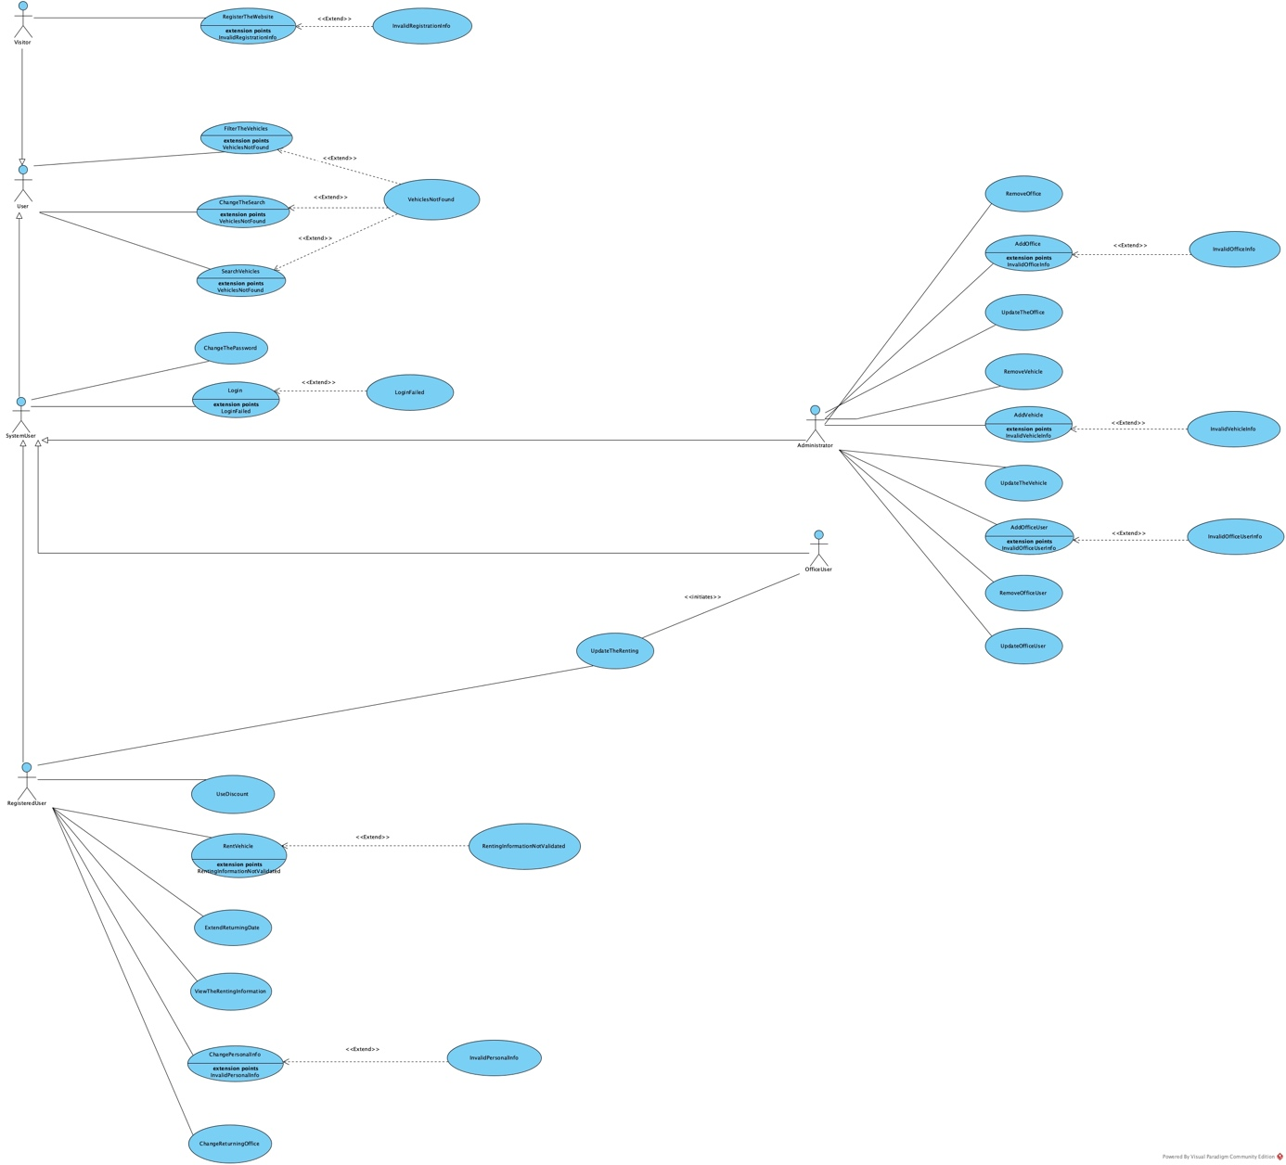

*Fig 1.1: Use case diagram for the VehicleRentingSystem.*

**Use case name** SearchVehicles

**Participating actors** Initiated by User

**Flow of Events**

1. User enters to the search panel displayed on the homepage of website and enters the information of the name of the receiving office, the name of the returning office, the receiving date of the vehicle and the returning date of the vehicle. Then RegisteredUser activates the list vehicles function of the VehicleRentingSystem
2. VehicleRentingSystem responds to the User by displaying a list of vehicles on the page which matches to the information on search panel.
3. On that page, User views the vehicles

listed in increasing order based on their renting prices and tagged with their model name along with the price information.

**Entry Condition -** The User is logged into VehicleRentingSystem.

**Exit Condition -** The User has directed to a new page with a

list of vehicles which is displayed as a

response from the VehicleRentingSystem.

**Use case name** VehiclesNotFound

**Participating actors** Communicates with RegisteredUser

**Flow of Events**

1. There is not found any available vehicles by

VehicleRentingSystem which matches any of

the information on search panel fields.

2. VehicleRentingSystem displays an informative

message to RegisteredUser about

there is no available vehicles to be listed.

**Entry Condition**

It extends the ListVehicles and ChangeTheSearch use case.Initiated by the

VehicleRentingSystem, when there is no available

vehicles to show RegisteredUser which matches the

information that RegisteredUser entered on search panel.

**Exit Condition** The RegisteredUser receives a message about there

are no available vehicles to be displayed

as a response from VehicleRentingSystem.

**Use case name** ExtendReturningDate

**Participating actors** Initiated by RegisteredUser

**Flow of Events**

1. RegisteredUser enters the “My Profile” page of the website, then scroll down on page and moves into the new page, “My Rentings”. On that page, RegisteredUser sees the list of the rentings which is displayed by VehicleRentingSystem based on RegisteredUser’s current and past rentings.
2. RegisteredUser goes into, selects the detail of the current renting that he/she choses and activates the extend returning date function.
3. VehicleRentingSystem responds to the RegisteredUser by presenting a list of appropriate dates for returning date.
4. Then, RegisteredUser selects one of the dates on the list and activates the Save the Returning Date function.
5. VehicleRentingSystem saves the new returning date of this selected current renting of RegisteredUser. Then, displays an informative message of “Saved Successfully” to the RegisteredUser .

**Entry Condition** RegisteredUser is logged into VehicleRentingSystem.

**Exit Condition**

RegisteredUser has received an message from VehicleRentingSystem which is the change in returning date is saved successfully as a response.

**Use case name** UpdateTheRenting

**Participating actors** Initiated by OfficeUser

Communicates with RegisteredUser

**Flow of Events**

1. RegisteredUser delivers the vehicle to the OfficeUser at returning office. RegisteredUser fills out necessary forms and OfficeUser takes these forms. Following, OfficeUser logs into the website with its password and username and enters the “Rentings” page of the website.
2. VehicleRentingSystem responds by displaying the all rentings as a list on the page.
3. First OfficeUser locates the corresponding renting of the OfficeUser by using his social security number and activates the manage the renting function of the system for that renting. Then, OfficeUser changes the renting status of the vehicle as “received” and checks out the information on form by using the information on the corresponding renting. Following, OfficeUser uploads the documents which is filled out by the RegisteredUser to the corresponding renting. After, OfficeUser activates the “save the changes” function of the system.
4. VehicleRentingSystem response to OfficeUser by saving the changes and displays a message of “Saved successfully” to the OfficeUser.

**Entry Condition** RegisteredUser delivers his/her rented vehicle at the returning date which is specified in his/her renting to the OfficeUser which works in the returning office specified in the renting of the RegisteredUser as returning office.

**Exit Condition** OfficeUser finishes and saves the renting process

for the corresponding RegisteredUser.

**Use case name** ChangeTheSearch

**Participating actors** Initiated by User

**Flow of Events**

1. User enters the information such that the name of the receiving office, the name of the returning office, the receiving date of the vehicle and the returning date of the vehicle to the search panel which is on the homepage of the website. Then RegisteredUser activates the list vehicles function of the VehicleRentingSystem.
2. VehicleRentingSystem responds to the User by displaying a list of vehicles on the page which matches to the information on search panel.
3. On that page, User views the vehicles

listed in increasing order based on their renting prices and tagged with their model name along with the price information. Following, RegisteredUser notices the panel which displays the returning date, receiving date, returning office and receiving office information of the current search. On this panel, RegisteredUser changes at least one of the fields and activates change the search function.

1. VehicleRentingSystem responds to the User by displaying a list of vehicles on the page which is corresponding to the new search information.

**Entry Condition** User logs into the VehicleRentingSystem.

**Exit Condition** The User has directed to a page

which displays a list of vehicles corresponding to the new search information entered by the User which is displayed as a response from the VehicleRentingSystem.

**Use case name**  RentVehicle

**Participating actors** Initiated by RegisteredUser

**Flow of Events**

1. RegisteredUser enters the information such that the name of the receiving office, the name of the returning office, the receiving date of the vehicle and the returning date of the vehicle. Then RegisteredUser activates the list vehicles function of the VehicleRentingSystem
2. VehicleRentingSystem responds to the RegisteredUser by displaying a list of vehicles on the page which matches to the information on the search panel.
3. On the page, RegisteredUser views the vehicles

listed in increasing order based on their renting prices and tagged with their model name along with the price information. Afterwards, RegisteredUser selects a vehicle from the list and adds to its chart. Then, RegisteredUser opens its chart and activates the checkout function of the system.

1. VehicleSystem displays a page which includes a personal information form and payment information form as a response. If the RegisteredUser had a saved personal information in his/her profile, the VehicleRentingSystem fills out the personal information section in the corresponding form. If this is not the case, the VehicleRentingSystem displays the personal information form as empty. After that, the RegisteredUser fills out the fields of the payment information form which are the name, surname, address, social security number and credit/debit card information and then confirms it. Also, he/she fills out the fields of the personal information form if the form is not filled out automatically. In addition to that, Although the personal information form is filled out automatically by the system, RegisteredUser can still change the fields of the form. Following, the RegisteredUser activates the complete the renting function of the system.
2. VehicleRentingSystem responses with displaying a message such that “Your renting is done succesfully.” on the website and sends an email to RegisteredUser which includes detailed information about renting.

**Entry Condition** RegisteredUser logs into the VehicleRentingSystem.

**Exit Condition**

RegisteredUser receives a message about renting process is successfully done and an email about the renting information from theVehicleRentingSystem as a response.

**Use case name** ViewTheRentingInformation

**Participating actors** Inıtiated by RegisteredUser

**Flow of Events**

1. RegisteredUser enters the “My Rentings” page of the website, then sees the list of the current and past rentings. Then, selects a one of the current rentings that he/she has own.
2. RegisteredUser goes into the detail of the current renting that he/she chose and activates the view renting function.
3. VehicleRentingSystem responses by directing RegisteredUser to the details of the renting.
4. Then, RegisteredUser notices the receiving date, returning date, receiving office, returning office, his/her personal information and the brief information about payment which includes the credit/ debit card’s name, bank name and the amount of the money he/she paid for his/her renting.

**Entry Condition** RegisteredUser logs into the VehicleRentingSystem

**Exit Condition** RegisteredUser views the renting information of

his/her renting in detail which the

VehicleRentingSystem has displayed as a response.

**Use case name** RentingInformationNotValidated

**Participating actors** Communicates with RegisteredUser

**Flow of Events**

1. The RegisteredUser enters an invalid information to the at least one of the fields in the personal information form or payment information form. An input is specified as invalidated by VehicleRentingSystem when it does not matches the information on the system or it have a incorrect syntax.
2. VehicleRentingSystem responds to RegisteredUser with displaying a message of “Invalid entry on field”.

**Entry Condition**

It extends the RentVehicle use case. Initiated by the VehicleRentingSystem when RegisteredUser is entered an invalid information on the fields of the personal information and/or payment information form.

**Exit Condition** The RegisteredUser receives a message of “Invalid

Entry on ”field” as a response from VehicleRentingSystem.

**Use case name** UseDiscount

**Participating actors** Inıtiated by RegisteredUser

**Flow of Events**

1. RegisteredUser enters the corresponding receiving date, receiving office, returning date and returning office informations to the search panel of the website.
2. Then, activates the list vehicles function of the system and notices the listed cars on the web page.
3. RegisteredUser uses the class filter function to find an appropriate vehicle for itself.
4. After, VehicleRentingSystem responds by displaying list of vehicles according to the filter information.
5. Then, RegisteredUser selects a vehicle form the list and adds it to her/his chart. Following, RegisteredUser enters its chart and selects one of her/his discounts. After, activates the use discount function.
6. The VehicleSystem responds to RegisteredUser by changing the total price on the chart by reducing the discount percentage and displays the reduced total price to RegisteredUser.

**Entry Condition** RegisteredUser logs into the VehicleRentingSystem

**Exit Condition** RegisteredUser views the reduced total price of

his/her renting on its chart which VehicleRentingSystem has displayed as a response.

**Use case name** ChangeReturningOffice

**Participating actors** Inıtiated by RegisteredUser

**Flow of Events**

1. RegisteredUser enters the “My Profile” page of the website, then scroll down on page and moves into the new page, “My Rentings”. On that page, RegisteredUser sees the list of the rentings which is displayed by VehicleRentingSystem based on RegisteredUser’s current and past rentings. RegisteredUser activates the view the renting function of the system.
2. VehicleRentingSystem displays the detailed information of the corresponding renting which includes personal information and billing information of the RegisteredUser. Then, activates the change the returning office function of the system.
3. VehicleRentingSystem responds to the RegisteredUser by presenting a list of appropriate office locations for returning office.
4. Then, RegisteredUser selects one of the offices on the list and activates the save the returning Office function.
5. VehicleRentingSystem saves the new returning Office location of entered by RegisteredUser. Then, displays a message such that “Saved Successfully” to the RegisteredUser.

**Entry Condition** RegisteredUser logs into the VehicleRentingSystem

**Exit Condition**

RegisteredUser has received a message from VehicleRentingSystem about the new returning Office location is saved succesfully.

**Use case name** RemoveVehicle

**Participating Actors** Initiated by Administrator

**Flow of Events** 1. The Administrator enters the “Vehicles” page which is in the Main Page of the of the website.

2. VehicleRentingSystem responds to the user by displaying the vehicles in the system.

3.The Administrator searches a car by its model number.

4.VehicleRentingSystem displays the appropriate car.

5.Administrator enters the information page of the car and activates the Removing Vehicle function of the VehicleRentingSystem for the selected car.

6.VehicleRentingSystem removes the selected car.

**Entry condition -** The Administrator is logged into the VehicleRentingSystem

**Exit condition -** The RegisteredUser has received an information and selected response from the removing vehicle function of the VehicleRentingSystem.

**Use case name** AddVehicle

**Participating Actors** Initiated by Administrator

**Flow of Events** 1. The Administrator enters the “Vehicles” page which is in the Main Page of the of the website.

2. VehicleRentingSystem responds to the user by displaying the vehicles in the website.

3.The Administrator activates the Add Vehicle function of the VehicleRentingSystem.

4.VehicleRentingSystem displays a blank form which include model number, daily price, class name, gear type, fuel type, number of seats, available luggage amount, kilometer and location of the Vehicle.

5.Administrator fills out at least each field in the form except location information and confirms.

6.VehicleRentingSystem saves a new vehicle to the website. Then, it displays a information which is “Your vehicle is added successfully” to the Administrator. If at least one of the information except location of the car is empty or wrong, VehicleRentingSystem initiates the WrongInput use case.

**Entry condition -** The Administrator is logged into the VehicleRentingSystem

**Exit condition -** The RegisteredUser has received an information and selected response from the VehicleRentingSystem.

**Use case name** ChangePersonalInfo

**Participating Actors** Initiated by RegisteredUser

**Flow of Events** 1. RegisteredUser enters the “My Profile” page which is in the Main Page of the of the website.

2. VehicleRentingSystem responds to the user by displaying personal information to the RegisteredUser.

3. RegisteredUser activates the change personal information function of the system.

4. VehicleRentingSystem displays the personal information of the RegisteredUser as editable

fields which includes the name, surname,username, birthdate, phone, e-mail, gender, address, city, country and driver-license information.

5. RegisteredUser changes the at least one the fields and confirms his input.

6.Finally, VehicleRentingSystem validates the changes and then displays a feedback on the screen as “Saved Succesfully.”

**Entry condition -** The RegisteredUser is logged into the VehicleRentingSystem

**Exit condition -** The RegisteredUser has received an information and selected response from the VehicleRentingSystem.

**Use case name** RegisterTheWebsite

**Participating Actors** Initiated by Visitor

**Flow of Events** 1. Visitor clicks the register button which is on the main page of the website.

2. VehicleRentingSystem responds to the user by displaying a blank form which has name, surname, email and username fields.

3. Visitor enters his name, surname, email and username to the form then confirms.

4 First, VehicleRentingSystem validates and then saves the information entered by Visitor to the system and it displays a feedback on the screen as “You have registered successfully”. Then, it sends an email to the Visitor.

**Exit condition -** The RegisteredUser has received an information and selected response from the VehicleRentingSystem.

**Use case name** UpdateTheOffice

**Participating Actors** Initiated by Administrator

**Flow of Events** 1. Administrator opens the “Offices Page” which is in the main page of the website.

2. VehicleRentingSystem responds to the user by displaying a list of Offices in the

VehicleRentingSystem.

3.Administrator enters the name of a office which will be managed.

4. VehicleRentingSystem Displays the corresponding office.

5. Administrator activates the manage office function of the system.

6.VehicleRentingSystem displays the information of the corresponding Office as

editable fields.

7. RegisteredUser changes at least one of the fields and confirms his/her input.

8.Finally, VehicleRentingSystem saves

information of the Office to the system and it displays a feedback on the screen as “Saved Succesfully.”

**Entry condition -** The Administrator is logged into the

VehicleRentingSystem.

**Exit condition -** The Adminstrator has received an information and selected response from the VehicleRentingSystem.

**Use case name** InvalidVehicleInfo

**Participating Actors** Initiated by Administrator

**Flow of Events** 1. Administrator receives a message which is “Your input is not validated” from the VehicleRentingSystem. An input is not validated by the VehicleRentingSystem when it does not matches the information in the system or it has a incorrect syntax or it is empty although it is a obligatory field.

**Entry condition -** It extends the AddVehicle use case. Initiated by the VehicleRentingSystem when Administrator confirms the inputs in the form and at least one of the fields is not validated by VehicleRentingSystem.

**Exit condition -** The Administrator has received an information and selected response from the VehicleRentingSystem.

**Use case name** InvalidPersonalInfo

**Participating Actors** Initiated by RegisteredUser

**Flow of Events** 1. The RegisteredUser receives a message such that “Your

input is not validated” from the VehicleRentingSystem. An

input is not validated by the VehicleRentingSystem in the

personal information form when it does not matches the

information in the system or it has a incorrect syntax or it does

not exists or it is empty although it is a obligatory field .

**Entry condition -** It extends the ChangePersonalInfo use case. Initiated by the VehicleRentingSystem when at least one of fields in corresponding page is not validated by the VehicleRentingSystem.

**Exit condition -** The RegisteredUser has received an information and selected response from the VehicleRentingSystem.

**Use case name** InvalidRegistrationInfo

**Participating Actors** Initiated by Visitor

**Flow of Events**

1. Visitor receives a message such that “Your

input is not validated” from the VehicleRentingSystem. An

input is not validated by the VehicleRentingSystem in the

registration form when it does not matches the information in

the system or it has a incorrect syntax or it is empty although it

is a obligatory field.

**Entry condition -** It extends the RegisterTheWebsite usecase. Initiated by the VehicleRentingSystem when at least one of fields in the registration form is not validated by the VehicleRentingSystem.

**Exit condition -** The RegisteredUser has received an information and selected response from the VehicleRentingSystem.

**Use case name** AddOffice

**Participating Actors** Initiated by Administrator

**Flow of Events** 1. Administrator opens the ”Offices” page of the website.

2. VehicleRentingSystem responds to the user by

Displaying a list of the offices in the system.

3. Administrator activates the “Add new Office” function of the

website.

4. VehicleRentingSystem displays a form which

İncludes the name, address, e-mail, phone, fax, working-hours, city and country of the Office.

5. Administrator fills out the form. Then he/she confirms his/her

input.

6. VehicleRentingSystem saves the his/her input

and then responds to the RegisteredUser by displaying a message such that “Office is added succesfully”.

**Entry condition -** The Administrator is logged in to the

VehicleRentingSystem with his/her username and password.

**Exit condition -** The Administrator received a message from the system about the corresponding Office is added succesfully to the system.

**Use case name** Login

**Participating Actors** Initiated by SystemUser

**Flow of Events** 1. SystemUser opens the login page of the website.

2. VehicleRentingSystem displays the form which consists of username and password.

3. SystemUser fills the own username and password. Then he

confirms the inputs.

4.VehicleRentingSystem validates the given inputs.

5. SystemUser notices that the current web page is changed to

the main page of the website and his/her name is displayed on the right-top of the website.

**Entry condition -**The SystemUser is logged in to the VehicleRentingSystem with his/her username and password.

**Exit condition -** The SystemUser is directed to the main page of the website by VehicleRentingSystem and noticed his/her name and surname on the right-top of the page.

**Quality requirement -** The VehicleRentingSystem must complete the login

operation at most 30 seconds.

**Use case name** FilterTheVehicles

**Participating Actors** Initiated by User

**Flow of Events** 1. User filters the listed Vehicles by using the search on the website in terms of at least the classes, gear types or fuel types of the Vehicles.

2. VehicleRentingSystem displays a list of Vehicles on the website which filtered by the corresponding inputs of the User.

**Entry condition -** The User is completed a search by using the search panel on the main page of the website through selecting a corresponding receving date, receiving Office, returning date and returning Office.

**Exit condition -** The User has received a car list.

**Use case name** RemoveOffice

**Participating Actors** Initiated by Administrator

**Flow of Events** 1. Administrator opens the ”Offices” page of the website.

2. VehicleRentingSystem responds to the user by

displaying a list of the Offices in the system.

3. Administrator chooses an Office.

4. VehicleRentingSystem displays detail of the

Office and OfficeUsers who works in that Office.

5. Administrator activates the “Remove Office” function of the

website.

6. VehicleRentingSystem displays a message such that “Office is removed succesfully”.

**Entry condition -** The Administrator is logged in to the VehicleRentingSystem with his/her username and password.

**Exit condition -** The Administrator received a message from the system about the corresponding Office is removed succesfully to the system.

**Use case name** AddOfficeUser

**Participating Actors** Initiated by Administrator

**Flow of Events** 1. Administrator opens the ”Offices” page of the website.

2. VehicleRentingSystem responds to the user by

displaying a list of the Offices in the system.

3. Administrator chooses an Office.

4. VehicleRentingSystem displays detail of the

office and OfficeUsers who works in that Office.

5. Administrator activates the “Add Office User” function of the

website.

6. VehicleRentingSystem displays a form which

includes name, surname, birthdate, phone, office, e-mail, username, password, gender, address, city and country of the OfficeUser.

7. Administrator fills out the form. Then he confirms his/her input.

8. VehicleRentingSystem saves the his/her input

and then responds to the RegisteredUser by displaying a message such that “OfficeUser is added succesfully”.

**Entry condition -** The Administrator is logged in to the VehicleRentingSystem with his/her username and password.

**Exit condition -** The Administrator received a message from the system about the corresponding OfficeUser is added succesfully to the system.

**Use case name** UpdateOfficeUser

**Participating Actors** Initiated by Administrator

**Flow of Events** 1. Administrator opens the ”Offices” page of the website.

2. VehicleRentingSystem responds to the user by

displaying a list of the Offices in the system.

3. Administrator chooses an Office .

4. VehicleRentingSystem displays detail of the

office and OfficeUsers who works in that Office.

5. Administrator chooses an OfficeUser.

6. VehicleRentingSystem displays information about OfficeUser.

7. Administrator activates the “Update Office User” function of the website.

8. VehicleRentingSystem displays detailed

information of the corresponding OfficeUser

9. Administrator changes at least one of the information of

OfficeUser. Then he/she confirms the inputs.

10.VehicleRentingSystem saves the his/her input

and then responds to the RegisteredUser by displaying a message such that “OfficeUser is updated succesfully”.

**Entry condition -** The Administrator is logged in to the VehicleRentingSystemwith

his/her username and password.

**Exit condition -** The Administrator received a message from the system about the corresponding OfficeUser is updated succesfully to the system.

**Use case name** LoginFailed

**Participating Actors** Communicates with RegisteredUser

**Flow of Events** 1. The RegisteredUser receives a feedback from the system

such that “ Your username or password is wrong.”. An input

is specified as invalidated by VehicleRentingSystem when it

does not matches the information on the system or it is empty.

**Entry condition -** It extends the Login use case. Initiated by VehicleRentingSystem when on the login page of the system, the entered username or

password by RegisteredUser is not validated from the

VehicleRentingSystem.

**Exit condition -** The RegisteredUser receives a selected response from

VehicleRentingSystem.

**Use case name** InvalidOfficeInfo

**Participating Actors** Communicates with Administrator

**Flow of Events** 1. The Administrator receives a feedback from the system

such that “ Your input is invalid.”. An input is specified as

invalidated by VehicleRentingSystem when it does not

matches the information on the system or it have a incorrect

syntax or it is empty.

**Entry condition** - It extends the AddOffice use case. Initiated by

VehicleRentingSystem when at least one of the information in the fields of the add Office form is not validated from system.

**Exit condition -** The Administrator receives a selected response from

VehicleRentingSystem.

**Use case name** InvalidOfficeUserInfo

**Participating Actors** Communicates with Administrator

**Flow of Events** 1. The Administrator receives a feedback from the system such

that “ Your input is invalid.”.An input is specified as invalidated

by VehicleRentingSystem when it does not matches the

information on the system or it have a incorrect syntax or it is

empty.

**Entry condition** - It extends the AddOfficeUser use case. Initiated by

VehicleRentingSystem when at least one of the information in the fields of the add OfficeUser form is not validated from system.

**Exit condition -** The Administrator receives a selected response from

VehicleRentingSystem.

**Use case name** RemoveOfficeUser

**Participating Actors** Initiated by Administrator

**Flow of Events** 1. Administrator opens the ”Offices” page of the website.

2. VehicleRentingSystem responds to the user by

displaying a list of the offices in the system.

3. Administrator chooses an Office .

4. VehicleRentingSystem displays detail of the

Office and OfficeUsers who works in that Office.

5. Administrator chooses an OfficeUser.

6. VehicleRentingSystem displays information

about OfficeUser.

7. Administrator activates the “Remove Office User” function of the website.

8.VehicleRentingSystem displays a

message such that “OfficeUser is updated succesfully”.

**Entry condition -** The Administrator is logged in to the VehicleRentingSystem with his/her username and password.

**Exit condition -** The Administrator received a message from the system about the corresponding OfficeUser is removed succesfully to the system.

**Use case name** UpdateTheVehicles

**Participating Actors** Initiated by Administrator

**Flow of Events** 1. Administrator opens the ”Vehicles” page of the website.

2. VehicleRentingSystem responds to the user by

displaying a list of the vehicles in the

system.

3. Administrator chooses an Vehicle .

4. VehicleRentingSystem displays detail of the

vehicle.

5. Administrator activates the “Update Vehicle” function of the website.

6.VehicleRentingSystem displays a message

such that “Vehicle is updated succesfully”.

**Entry condition -** The Administrator is logged in to the

VehicleRentingSystem with his/her username and password.

**Exit condition -** The Administrator received a message from the system about the corresponding Vehicle is updated succesfully to the system.

### 

### Object model

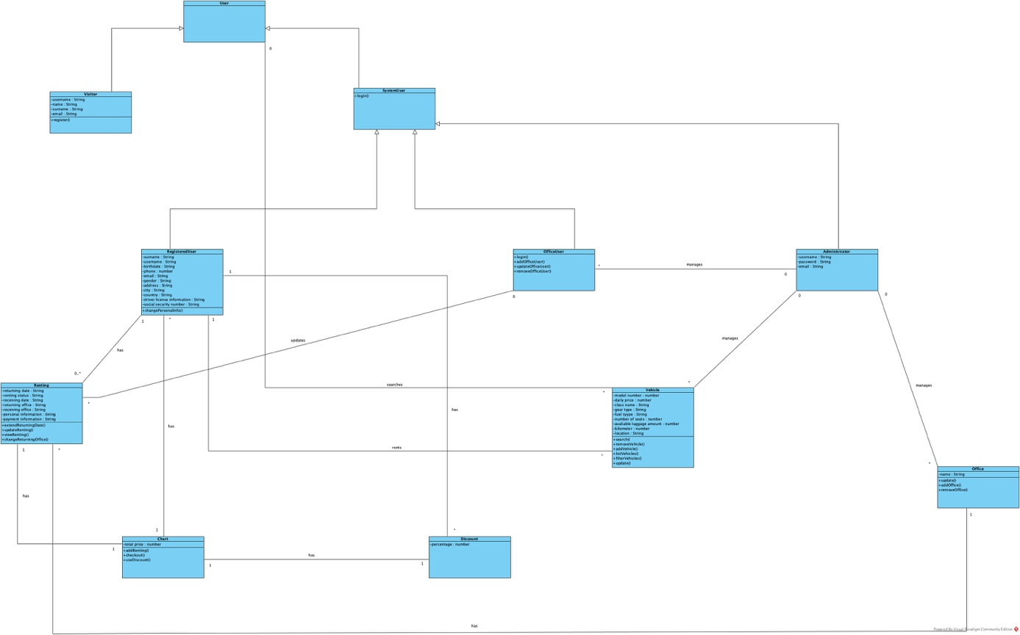

*Fig 1.2: The UML Class diagram of the VehicleRentingSystem which consists of entity objects.*

### Dynamic model

The Dynamic model is consists of sequence diagrams of the each use case. You can find the corresponding diagrams in the Diagrams1.vpp and Diagrams2.vpp files as Visual Paradigm Diagrams. Three major examples of the sequence diagrams are given below:

ekran görüntüsü içeren bir resim

Açıklama otomatik olarak oluşturuldu

*Fig 1.3: The sequence diagram of the RegisterTheWebsite use case.*

*ekran görüntüsü içeren bir resim

Açıklama otomatik olarak oluşturuldu*

*Fig 1.4: The sequence diagram of the ChangeThePersonalInfo use case.*

*ekran görüntüsü içeren bir resim

Açıklama otomatik olarak oluşturuldu*

*Fig 1.5: The sequence diagram of the UpdateTheVehicle use case.*

### 

### User interface—navigational paths and screen mock-ups

Screen mock-ups is prepared as a Balsamiq Mockups project. You can find the corresponding project in the project file. Five major examples of the mockups are given below:

ekran görüntüsü içeren bir resim

Açıklama otomatik olarak oluşturuldu

*Fig 1.6: The screen mockup of the Homepage for the Visitor.*

*ekran görüntüsü içeren bir resim

Açıklama otomatik olarak oluşturuldu*

*Fig 1.6: The screen mockup of the “search for renting” page for the Visitor.*

*.*

*ekran görüntüsü içeren bir resim

Açıklama otomatik olarak oluşturuldu*

*Fig 1.7: The screen mockup of the Offices page for the Administrator.*

*ekran görüntüsü içeren bir resim

Açıklama otomatik olarak oluşturuldu*

*Fig 1.8: The screen mockup of the My Profile page for the RegisteredUser.*

ekran görüntüsü içeren bir resim

Açıklama otomatik olarak oluşturuldu

*Fig 1.9: The screen mockup of the Vehicles page for the RegisteredUser.*

## Project Schedule

The project schedule is specified by using a Gantt Chart. You can find the detailed Gantt Chart as a .pdf document in the project file. A simplified chart is given below:

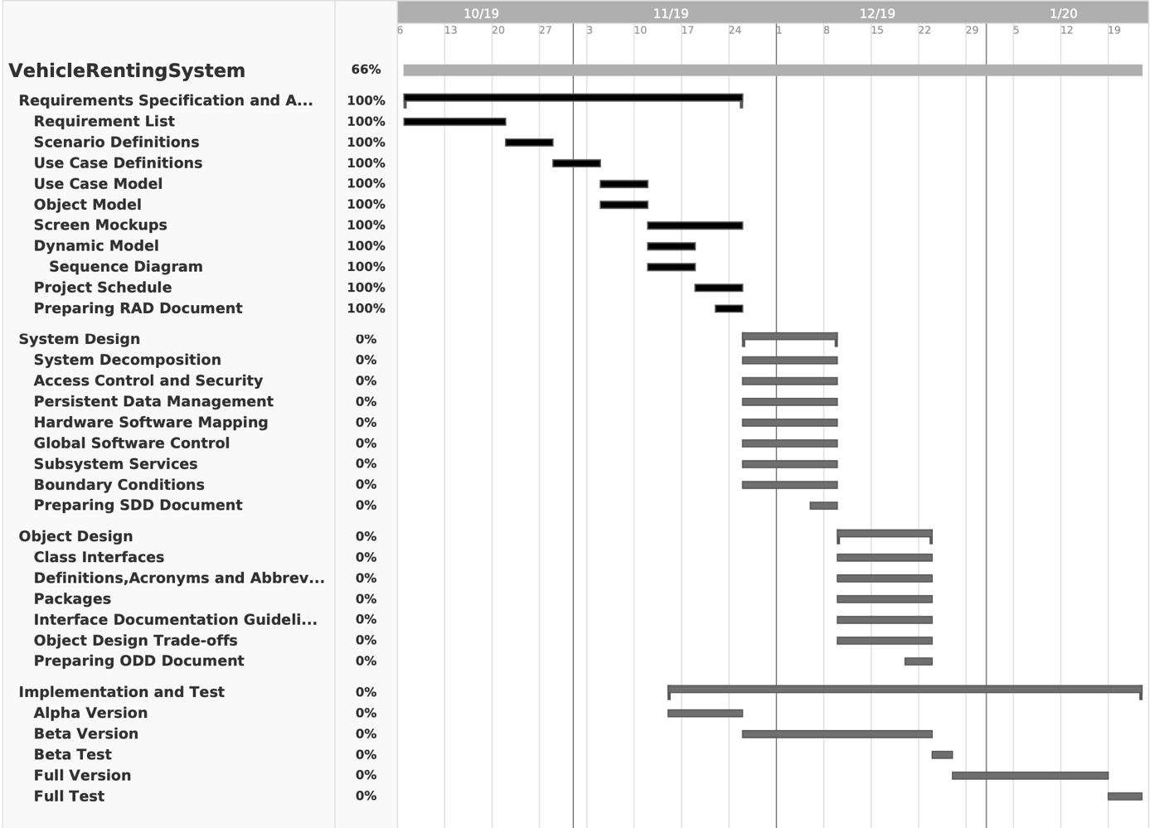

*Fig 1.3: The simplified Gantt Chart of the VehicleRentingSystem project. Note that you can find the detailed chart in the project file.*

# Glossary

***Entity Objects***

**Administrator:** A user of the system who manages the Vehicles, Offices and OfficeUsers. An administrator adds, removes and update Offices, Vehicles and OfficeUsers.

**Vehicle:** A Vehicle is a car object in the system. It is denoted with its model number, daily price, class name, gear type, fuel type, number of seats, available luggage amount, kilometer and location of the car.

**Office:** Offices are objects that consists of many Vehicles. VehicleRentingSystem has many Offices and there are many OfficeUsers who works in these Offices of the system.

**User:** User is someone who uses the VehicleRentingSystem and must be either SystemUser or Visitor. The User can search the available vehicles on the system, filter the vehicles after search and after a completed search, they can change the search parameters to do new search.

**Visitor:** Visitor is an user on the system who isn’t registered to the system. They can register to the system.

**SystemUser:** SystemUser is an user on the system who is registered to the system. Identified as its username and password. Must be either OfficeUser or Administrator or RegsiteredUser. They can log into the VehicleRentingSystem and change their password.

**RegisteredUser:** RegisteredUser is a SystemUser on the system. Identified by their username and their email. They can rent vehicles, use their discount, extend their renting’s returning date, change their renting’s returning office, view their renting’s information and change their personal information.

**OfficeUser:** OfficeUser is a SystemUser on the System. Identified by their username and their email. They can update the renting of RegisteredUser.

**Renting:** Renting is an object which is created when RegisteredUsers rent vehicles on the system. They consists of returning date,receiving date, returning office, receiving office of the Renting and personal information and payment information of the RegisteredUser.

**Chart:** Chart is an object which holds the Rentings of RegisteredUsers. It consists of the total price of the corresponding Renting and the selected discount of RegisteredUser.

**Discount:** Discount is a promotion which used for reducing the total price of a Renting with a percentage.

***Boundry Objects***

**VehicleList:** A list displayed on the page by VehicleRentingSystem which consists of all Vehicles in the system.

**VehicleDetails:** A form which consists of details of a specific Vehicle.

UpdateVehicleMessage: A pop-up message which specifies that corresponding Vehicle is updated succesfully.

**InvalidVehicleInfo:** A message which specifies that you entered a invalid vehicle information to one of the fields in the VehicleDetails.

**OfficeList:** A list displayed on the page by VehicleRentingSystem which consists of all Offices in the system.

**OfficeDetails:** A form which consists of details of a specific Office.

**OfficeSaved:** A pop-up specifies that corresponding office is updated succesfully.

InvalidOfficeInfo: A message shows that you entered an invalid office information to the OfficeDetails.

**RegisterButton:** A button which directs the User to the registration page.

**RegistrationForm:** A form which consists of required fields to register the VehicleRentingSystem which are username, name, surname, email and password.

RegistrationMessage: A pop-up shows that you registered the system succesfully.

InvalidRegistrationInfo: A message specifies that you entered a invalid info in to the RegistrationForm.

**PersonalInformation:** A button in the profile page of the RegisteredUsers which directs them to details of their personal information.

PersonalInfoDetails: A form which consists of the personal information of a RegisteredUser which are name, surname , birthdate, phone, e-mail, gender, address, city, country and driver-license information.

**OfficeUserList:** A list of OfficeUsers in a Office.

OfficeUserDetails: A form which shows the detailed information of a OfficeUser includes their name, surname, birthdate, phone,office, e-mail, username, password, gender, address, city and country

**RemoveOfficeUserMessage:** A po-up which specifies that corresponding OfficeUser is remove succesfully.

**FilteredVehicleList:** A list of Vehicles in the system which filtered in terms of their classes, names, model numbers, types, gears or plate numbers.

VehicleRemovedMessage: A message which specifies that corresponding Vehicle is remove succesfully.

**AddOfficeButton:** A button which opens the NewOfficeForm.

**NewOfficeForm:** A form to the add new Offices to the system which consists of the name, address, e-mail, phone, fax, working-hours, city and country of the Office.

**NewOfficeAdded:** A pop-up specifies that Office is added to the system succesfully.

**InvalidOfficeInfo:** A message shows that you entered an invalid information to the NewOfficeForm.

**SearchPanel:** The panel to search vehicles on the homepage of the website which consists of the fields receiving date, receiving office, returning date and returning office.

**SearchList:** A list of vehicles according to inputs taken in the SearchPanel.

VehicleIsNotFound: SearchController is not found any Vehicles according to given inputs.

**OfficeRemoved:** A pop-up message shows that the corresponding Office is removed succesfully.

**OfficeUserList:** A list of OfficeUsers in an Office.

**OfficeUserUpdated:** A message shows that the corresponding OfficeUser is updated succesfully.

**OfficeUserDetails:** A form consists of the information of a specific OfficeUser.

**InvalidOfficeUserInfo:** A message shows that you entered an invalid information to the OfficeUserDetails.

**NewOfficeUser:** A form consists of the name, surname, birthdate, phone, office, e-mail, username, password, gender, address, city and country of the OfficeUser to add OfficeUser into the system.

**OfficeUserAdded:** A message shows that the corresponding OfficeUser is added to the system succesfully.

**RentingList:** A list consists of Vehicles which are rented by RegisteredUser.

**RentingInformation:** A detailed information on the Renting’s returning office,receiving office, receivingDate, returningDate

**SavedMessage:** Message which is displayed to RegisteredUser to notify the fact that the changes on Renting are saved.

**VehiclesNotFound:** An exception which happens when there is no available Vehicle on the VehicleRentingSystem.

**SuccessfulRentingMesasage:** A message which is displayed to RegisteredUser to notify the fact that the Renting is successfully done.

**RentingInformationNotValidated:** An exception which happens when RegisteredUser entered an invalid information on either one of the PersonalInformationForm or PaymentInformationForm.

**PersonalInformationForm:**This form presented to RegisteredUser on the process of checkout when RegisteredUser has no saved personal information.

The form consists of fields which includes all the attributes of a personal information form.

**PaymentInformationForm:** This form presented to RegisteredUser on the process of checkout. The form consists of fields which includes all the attributes of a payment information form.

**ChartView:** A view which shows the corresponding chart of a RegisteredUser.

**FilteredVehicle:** Vehicles which are filtered corresponding to the information which RegisteredUser is provided such as receiving office, receiving date, returning office and returning date.

***Controllers***

**VehicleController:** A controller which adds, removes and updates Vehicles in the system.

**OfficeController:** A controller which adds, removes and updates Offices in the system.

**RegistrationController:** A controller which registers visitors.

**RegisteredUserController:** A controller which adds, removes and updates RegisteredUsers in the system.

**SearchController:** A controller which search Vehicles in the system.

**RentingController:** Controls the Change returning date function of a Renting, controls the update renting function of a Renting, controls the view/display of renting information, controls the change returning office function of a Renting.

# References

1. Bruegge B. & Dutoit A.H.. (2010). *Object-Oriented Software Engineering Using UML, Patterns, and Java*, Prentice Hall, 3rd ed.
2. [www.enterprise.com.tr](http://www.enterprise.com.tr) (the website which we take as an example in the project)
3. [www.europcar.com](http://www.europcar.com) (we took many examples from that website as well)